Non-EFT Nuclear Recoils as a Signature of Neutral Hopfion Topology
Research Team, Dust LLC
May 8, 2026
Subject areas: Foundations of Physics / Direct Detection / Topological Solitons / Dark-Sector Phenomenology
Keywords: neutral Hopfion, non-EFT recoil spectra, phase topology, nuclear recoils, form factors, direct detection
Preprint-style manuscript. Draft for theoretical and phenomenological review.

Executive Summary
This paper develops a phenomenological direct-detection framework for neutral Hopfion topology. The neutral Hopfion is treated as a finite, neutral, topological excitation whose local abundance or flux is an empirical parameter, not as the assumed cosmological dark matter particle of Phase Theory. This framing keeps the analysis tied to measurable recoil spectra while avoiding an over-identification that is not required by the underlying Phase Theory manuscript.
The central claim is that a neutral Hopfion recoil signal, if present, should not be described merely as a rate excess over background. Its defining feature would be spectral shape. Because the object is finite-size and topological rather than pointlike, its elastic nuclear recoil amplitude should contain a nonlocal overlap kernel and an intrinsic topological form factor. The resulting momentum-transfer dependence is generically non-polynomial in q^2. A finite direct-detection EFT expansion can approximate such a signal only in the low-qR_H limit, not reproduce it globally over a broad recoil-energy interval.
The paper therefore proposes a shape-first search program. A credible analysis should compare background-only models, standard spin-independent and spin-dependent templates, finite nonrelativistic EFT operator bases, generic finite-size composite templates, and Hopfion-motivated nonlocal templates. The primary discovery statistic should be a shape-only likelihood in which the unknown local Hopfion flux normalization is profiled out. The relevant question is not whether a detector observes events, but whether the observed energy dependence requires a nonlocal topological kernel after known backgrounds and detector response are included.
The strongest near-term experimental setting is xenon, led by LZ and XENONnT, because large exposure and low background enable spectral-shape tests in the keV nuclear recoil regime. Argon, germanium, and silicon targets remain essential because a genuine topological finite-size signal must transform coherently under changes of target mass, nuclear radius, threshold, and response model. Multi-target consistency is therefore elevated from a useful cross-check to a falsification requirement.
This work is not a completed ultraviolet derivation of Hopfion-nucleus scattering. It is a detector-facing bridge between phase-topological theory and recoil spectroscopy. The next theoretical milestones are a first-principles overlap kernel, lattice relaxation of the Q_H=1 neutral Hopfion, detector-folded recoil templates, and an open likelihood package for xenon, argon, germanium, and silicon analyses.

Abstract
We develop a phenomenological framework for nuclear recoils induced by neutral Hopfion topology. In Phase Theory, physical excitations are modeled as topological sectors of a phase substrate, and non-EFT dark-sector recoil spectra are identified as a falsifiable prediction. In the related LPST Hopfion profile, the neutral Hopfion is described as a stable, localized, finite-size topological object with no electric, color, or weak charge and with possible rare elastic nuclear recoils induced by correlation-geometry overlap and finite-size form-factor effects. Here the neutral Hopfion is not assumed to be the cosmological dark matter of Phase Theory. Instead, its local flux or density is treated as an open phenomenological parameter. We construct a recoil amplitude that factorizes into a target response, an intrinsic Hopfion form factor, and a nonlocal topological overlap kernel. The resulting spectra are generically non-polynomial in momentum transfer and cannot be represented exactly by any finite low-order direct-detection EFT expansion. We derive rate expressions, define benchmark templates, identify spectral and target-comparison observables, and propose a shape-only likelihood strategy for xenon, argon, germanium, and silicon detectors. Conservative experimental language is adopted throughout: current xenon data demonstrate strong keV-scale recoil sensitivity, while sub-keV nuclear-recoil claims should be tied only to specific low-threshold analyses. The proposed program is falsifiable: a finite EFT fit, cross-target inconsistency, incompatible inferred size scale, or failed first-principles scattering simulation would disfavor the neutral-Hopfion interpretation.

I. Introduction
Direct searches for rare nuclear recoils have traditionally been framed as searches for weakly interacting massive particles or for nearby variations of pointlike dark-sector matter. In that framework, the nuclear recoil spectrum is often modeled through a local interaction, a mediator that can be integrated out, or a nonrelativistic effective operator basis organized in powers of momentum transfer, velocity, and spin [4-7]. This approach is powerful because it separates detector information from ultraviolet model assumptions, but it is not guaranteed to describe every possible neutral object that can scatter from a nucleus.
The present paper examines a different possibility. A neutral Hopfion is a finite topological excitation rather than a pointlike field quantum. If such an object exists locally and can scatter elastically from nuclei, its recoil signature should carry information about its size, topology, and nonlocal correlation structure. The experimentally relevant question is therefore not only whether an excess exists, but whether the energy dependence of that excess can be compressed into a finite contact-operator expansion.
The title phrase non-EFT nuclear recoils is used in this operational sense. It does not mean that effective descriptions are useless. Rather, it means that the exact recoil kernel contains functions of qR_H that require an infinite tower of local operators if one tries to represent the signal using a point-particle expansion. A finite EFT truncation may fit a narrow low-momentum region, but it should fail once the detector probes the finite topological scale.
The paper follows the style and terminology of Phase Theory, which treats phase as the fundamental substrate and particles as stable topological sectors [1]. It also uses the LPST Hopfion profile, where the neutral Hopfion is described as a stable, neutral, localized topological object with rare elastic nuclear-recoil interactions mediated by correlation-geometry overlap and finite-size form-factor effects [2,3]. The analysis is phenomenological: it builds detector-facing templates without claiming that the full nonlinear phase dynamics have already been solved.

I.1. Scope
The manuscript makes four limited claims. First, a neutral Hopfion-like object can be modeled as an extended topological recoil source. Second, such an object naturally produces non-polynomial momentum-transfer structure. Third, that structure can be searched for using existing direct-detection analysis tools, provided that shape information is retained. Fourth, multi-target comparison is essential for rejecting ordinary backgrounds, detector artifacts, and conventional EFT explanations.
The manuscript deliberately does not identify the neutral Hopfion with the cosmological dark matter particle of Phase Theory. Phase Theory discusses neutral topological dark-sector sectors more generally and lists non-EFT recoil spectra as a falsifiable prediction [1]. The neutral Hopfion is treated here as a particularly clean test object for that class of phenomena.

I.2. Organization
Sec. II summarizes the theoretical inputs from Phase Theory, LPST, and the neutral Hopfion profile. Sec. III defines the neutral Hopfion as a finite topological scattering source. Sec. IV contrasts local EFT recoil templates with finite-size and topological recoil kernels. Sec. V introduces the phenomenological scattering ansatz. Sec. VI develops the predicted spectral morphology. Sec. VII describes the experimental program. Sec. VIII gives the likelihood strategy. Sec. IX states falsification criteria. Sec. X outlines the numerical roadmap. Sec. XI discusses limitations, and Sec. XII concludes.

II. Phase-Theory and LPST Inputs
Phase Theory proposes that phase is the sole primitive constituent of physical reality. Space, time, matter, light, and geometry are emergent structures arising from the global organization, topology, and consistency constraints of a phase-bearing substrate [1]. Within that framework, particles are stable, localized topological defects labeled by invariant data rather than fundamental pointlike fields. The relevant labels include phase winding k, knot charge Q_H, excitation level t, framing or chirality chi, and holonomy class R [1].
The direct connection to this paper is the Phase Theory prediction of non-EFT dark-sector recoil spectra. In that prediction, the nuclear recoil spectrum is not captured by a finite set of contact operators, because scattering is mediated by topological connectivity rather than by an ordinary local vertex [1]. This claim is not sufficient by itself to produce a detector template, but it fixes the class of observable: a non-polynomial momentum-transfer distribution.
LPST supplies a related substrate language. Its universal complex field is written L(x)=A(x) exp(i phi(x)), and geometry is derived from the correlation kernel C(x,y). Localized defects alter this kernel and thereby modify the emergent metric and local correlation geometry [2]. The LPST topological classification contains Hopfions through the pi_3(S^2) sector, with the Hopfion represented as a map S^3 to S^2 whose preimages of distinct target points are linked circles [2].

II.1. Neutral Hopfion profile
The uploaded Hopfion profile defines the benchmark object as a stable, neutral, localized Hopfion with k=0 and Q_H=1 [3]. Its characteristic size is stated to be larger than the Planck scale and typically smaller than or comparable to a proton, with a natural LPST range near 10^-18 to 10^-15 m [3]. Its mass is attributed to the energy cost of maintaining the knot rather than to Higgs coupling, and its electric, color, and weak charges are all zero [3].
The same profile states that the object does not bind electromagnetically, does not participate in chemistry, and is transparent to photons and ordinary matter except through rare higher-order effects. The possible direct-detection channel is rare elastic nuclear recoil through correlation-geometry overlap and finite-size form-factor effects [3]. These are exactly the ingredients required for a recoil spectrum that is finite-size, neutral, and nonlocal.

II.2. Non-identification with cosmological dark matter
The analysis treats the local Hopfion flux or density as an empirical nuisance parameter. This prevents the paper from relying on a stronger cosmological statement than is needed. A detector analysis can constrain the product of local flux and scattering strength even when the production history, halo abundance, and cosmological role of the object are not fixed.
Where a halo interpretation is useful for comparison with standard direct-detection notation, it is presented as an optional specialization. The primary equations are written in a flux-normalized form.

III. Neutral Hopfion Topology
A Hopfion is a topological soliton characterized by a Hopf invariant. In conventional mathematical language, the Hopf invariant classifies maps from S^3 to S^2 and measures the linking of preimages in physical space. This structure appears in Faddeev-Skyrme-type models and in knot-soliton studies [8-10]. The present paper does not import a particular Faddeev-Skyrme Lagrangian wholesale; it uses the Hopfion concept as the mathematically recognized finite topological structure underlying the neutral object described in LPST.
For a unit Hopfion, the invariant may be written schematically as
Q_H = (1 / 32π²) ∫ d³x εⁱʲᵏ A_i F_jk. (1)
Here F_jk is the pullback curvature of the internal orientation field and A_i is a corresponding potential. In this paper Q_H=1 is the benchmark topological sector. The exact normalization depends on conventions, but the invariant content is the linking of preimage loops.

III.1. Charge assignments and neutrality
The benchmark neutral sector is k=0 and Q_H=1. The vanishing of k means that the object carries no phase winding associated with electric charge. The Hopfion is neutral not because internal charged constituents cancel, but because the relevant charged winding is absent. This distinction matters experimentally. A charge-cancelled composite may still have polarizability, constituents, ionization channels, or ordinary substructure. The neutral Hopfion considered here is instead a pure finite topological texture.
The absence of electromagnetic, color, and weak charge removes the usual local scattering mechanisms. A recoil event, if present, is consequently attributed to overlap between the Hopfion correlation structure and the finite nucleus. This is the central reason that the expected momentum dependence differs from a pointlike WIMP interaction.

III.2. Finite size
Let R_H denote the characteristic Hopfion core size. The detector probes the dimensionless quantity x=qR_H, where q is the nuclear momentum transfer. For x much smaller than one, the internal structure is unresolved and the recoil spectrum can appear approximately contact-like. For x comparable to one, finite-size features enter. For x larger than one, the response can be suppressed, oscillatory, or otherwise shaped by the topology of the core.
This produces a natural hierarchy of regimes: an EFT-like low-q regime, a transition region in which topology becomes visible, and a high-q region where the overlap is suppressed by finite-size structure. The transition energy depends on both R_H and the target nuclear mass.

IV. Local EFT Versus Topological Recoil Kernels
The nonrelativistic EFT program for dark matter direct detection writes the scattering amplitude as a finite or truncated sum of Galilean-invariant operators built from momentum transfer, transverse velocity, dark-sector spin, and nucleon spin [4-7]. This is the correct general language for local point-particle scattering at low energy. It provides the natural null model for this paper.
The neutral Hopfion, however, is not assumed to couple through a local contact vertex. Its amplitude is expected to contain an intrinsic form factor. Finite-size composite dark-sector models already demonstrate that extended objects can alter recoil spectra through additional momentum-dependent form factors [11]. A Hopfion goes one step further: the finite-size function is not merely the Fourier transform of ordinary constituent density, but an effective transform of a knotted correlation texture.

IV.1. Operational definition of non-EFT
A recoil signal is called non-EFT here if the full detector-folded recoil spectrum cannot be represented exactly by any finite sum of local contact operators after backgrounds and nuisance parameters are included. Formally, for any finite n, the observed shape cannot be written as
dR_obs/dE_R ≠ dR_bkg/dE_R + Σ(a=1..n) c_a dR_a^EFT/dE_R for finite n. (2)
The symbol ≠ is used here in the statistical sense: no finite EFT family gives an adequate global likelihood fit once experimental response and background uncertainties are profiled.

IV.2. Small-q expansion
The non-EFT claim does not forbid a low-q expansion. Any smooth finite-size form factor has a Taylor expansion near qR_H=0. The point is that the expansion generally requires infinitely many terms to reproduce the full function:
F_H(qR_H) = 1 - a₂(qR_H)² + a₄(qR_H)⁴ - a₆(qR_H)⁶ + ... . (3)
A finite EFT truncation corresponds to retaining only finitely many terms in this series. The Hopfion hypothesis predicts that the omitted tail becomes experimentally relevant when qR_H is not negligible.

V. Phenomenological Scattering Framework
Consider elastic scattering of a neutral Hopfion H from a target nucleus T,
H + T → H + T. (4)

V.1. Kinematics
For a recoil energy E_R and target mass m_T, the nonrelativistic momentum transfer and minimum incident speed are
q = √(2 m_T E_R), v_min(E_R) = √[m_T E_R / (2 μ_HT²)]. (5)
μ_HT = m_H m_T / (m_H + m_T). (6)

V.2. Amplitude ansatz
The minimal detector-facing amplitude is written as
M_T(q,v) = g_top S_T(q,v) K_top(q; α_corr) F_H(qR_H; η_chi) F_T(q). (7)
S_T is the leading coherent target response, F_T is the ordinary nuclear form factor, F_H is the intrinsic Hopfion form factor, and K_top is the nonlocal correlation-overlap kernel. The factorization is a phenomenological ansatz, not a completed ultraviolet derivation.

V.3. Benchmark form factor
A flexible benchmark for the intrinsic Hopfion form factor is
F_H(x; η_chi) = exp(−x²/2) [1 + η_chi sin(x)/x] / (1 + η_chi), x=qR_H. (8)
K_top(q; α_corr) = [1 + α_corr² q²]⁻². (9)
Equations (8) and (9) are benchmark search templates. Other kernels can be substituted once first-principles simulations determine the Hopfion-nucleus overlap more precisely.

V.4. Flux-normalized and density-normalized rates
The primary rate expression is flux-normalized,If a halo interpretation is introduced for comparison with standard direct-detection notation, the rate becomes
dR_T/dE_R = Φ_H ∫ d³v f_H(v) dσ_T/dE_R. (10)
dR_T/dE_R = [ρ_H/(m_H m_T)] ∫_{v>v_min} d³v f_H(v) v dσ_T/dE_R. (11)
dσ_T/dE_R = [m_T/(2πv²)] |M_T(q,v)|². (12)

V.5. Interpretation of parameters
The parameters m_H and R_H describe the mass and size of the topological object. The coefficient g_top is not a Standard Model gauge coupling; it summarizes the strength of the effective overlap between nuclear and Hopfion correlation structures. The parameter alpha_corr sets the nonlocal correlation length of the overlap kernel, and eta_chi controls the strength of topology-induced oscillatory or holonomy-like deformation in the intrinsic form factor.

VI. Recoil-Spectrum Morphology
The most important observable is the shape of dR/dE_R. Since q=(2m_T E_R)^(1/2), a non-polynomial function of qR_H appears as a nontrivial function of the square root of recoil energy. This can produce curvature that is not captured by a small number of powers of E_R.
Figure 1 illustrates three normalized form-factor families: a pointlike contact template, a smooth finite-size template, and a Hopfion benchmark with nonlocal and oscillatory components. The figure is not a prediction of a unique ultraviolet model. It shows the class of spectral deformation that motivates a dedicated search.

VI.1. Target dependence
For the same recoil energy, a heavier target corresponds to a larger momentum transfer. Xenon can therefore probe finite-size curvature more strongly at fixed E_R, while argon, germanium, and silicon provide crucial checks because the same intrinsic R_H maps to different recoil-energy features. Figure 2 shows illustrative shape-normalized spectra for xenon, germanium, and argon using the same benchmark form factor.
A genuine Hopfion interpretation requires that the inferred m_H, R_H, alpha_corr, and eta_chi remain consistent across targets after detector response and nuclear form factors are included. If xenon requires one radius and argon requires an incompatible radius, the topological interpretation fails.

VI.2. Temporal observables
Temporal tests are secondary but valuable. A halo-like population may produce annual modulation. A stream or clump population may produce burstiness or cross-detector correlations. The relevant quantities include the annual modulation amplitude, the event-time separation distribution, and lagged cross-correlations between experiments. These tests cannot replace spectral-shape analysis, but they can help distinguish a physical flux from detector artifacts.
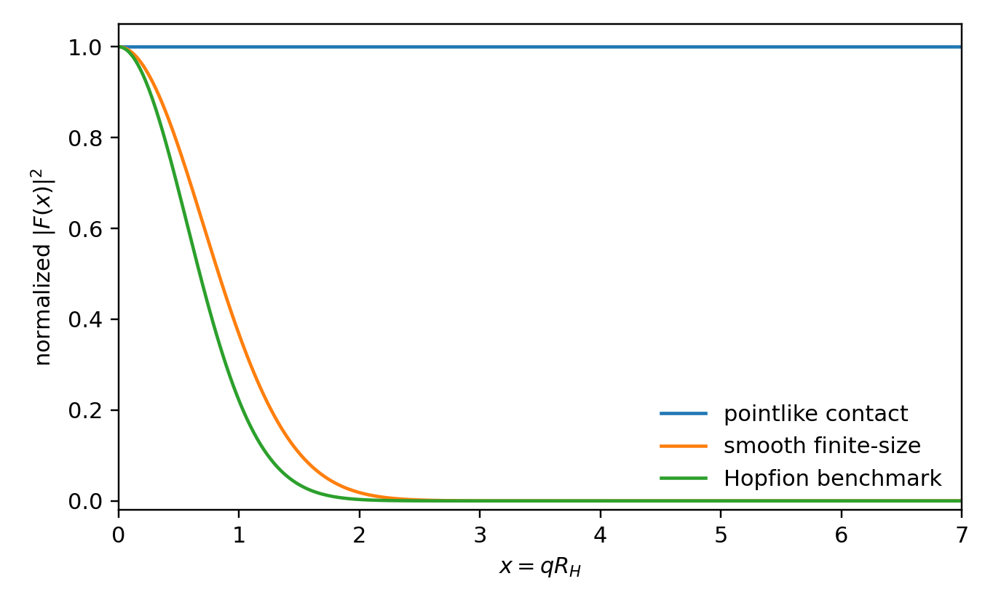
Figure 1. Illustrative form-factor families. The Hopfion benchmark combines finite-size damping with a nonlocal overlap factor and a topology-motivated oscillatory component. The curves are search templates, not first-principles predictions.
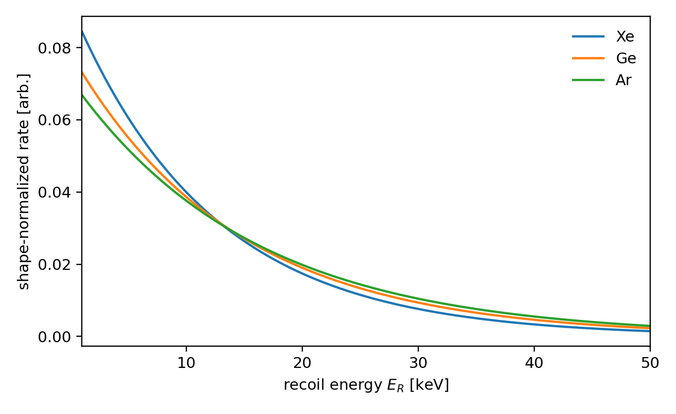
Figure 2. Illustrative shape-normalized recoil spectra for xenon, germanium, and argon using the same intrinsic benchmark form factor. Target dependence provides a central falsification test.

VII. Experimental Program
The experimental program should be xenon-led but multi-target by design. Xenon experiments provide the exposure and background control needed for shape analysis. Argon, germanium, and silicon provide complementarity in target mass, nuclear response, threshold, and detector systematics.
The language in this paper is deliberately conservative. Public LZ and XENONnT nuclear-recoil searches demonstrate strong sensitivity in the keV-scale recoil regime. Claims about sub-keV nuclear-recoil reach should be made only for a specific low-threshold or S2-only analysis, not as a blanket property of standard WIMP search channels.

VII.1. Xenon
LZ has reported a WIMP nuclear-recoil search using 4.2 tonne-years of exposure over 280 live days, with no significant excess over expected backgrounds and leading constraints for WIMP masses above the stated range of that analysis [12]. A separate LZ low-energy analysis reports 5.7 tonne-years of exposure, an energy interval spanning 1-6 keV, and evidence for solar 8B coherent elastic neutrino-nucleus scattering at keV-scale energies [13]. These results motivate a xenon-first non-EFT shape analysis, but they do not by themselves establish a neutral Hopfion signal.
XENONnT provides an independent xenon comparison. Its first nuclear recoil search used approximately 1.1 tonne-year exposure, a sensitive xenon mass of 5.9 t, and an energy range from 3.3 to 60.5 keV [14]. Any Hopfion-like spectral shape in xenon should be checked against both LZ and XENONnT response models.

VII.2. Argon, germanium, and silicon
DarkSide-20k is designed around a two-phase liquid argon time projection chamber with a nominal 20 t fiducial mass [15]. Argon provides a target-mass lever arm relative to xenon and different background systematics. SuperCDMS SNOLAB is designed for low-mass dark matter sensitivity using cryogenic germanium and silicon detectors [16]. These targets are especially valuable if the preferred Hopfion mass or size pushes the feature toward lower recoil energies.
The target-complementarity literature emphasizes that multiple detector materials help separate particle parameters from astrophysical and nuclear uncertainties [17]. The same logic applies here, but with greater force: the topology claim is a shape claim, and a shape claim must survive changes of target.

VII.3. Directional and future detectors
Directional recoil concepts such as CYGNUS would add information about incident direction and could test halo, stream, or clump interpretations if a non-EFT spectral excess were ever observed [18]. Multi-ten-ton xenon concepts would be valuable for precision shape reconstruction, but the first phase of the program should emphasize open template development and reanalysis of existing keV-scale nuclear recoil data.

VIII. Statistical Strategy
Because the local neutral Hopfion abundance is unknown, the first analysis should profile out normalization and focus on shape. Let n_i be observed counts in recoil bin i, and let mu_i(theta,nu) be predicted counts for signal parameters theta and nuisance parameters nu. A shape-only likelihood can be written as
ln L_shape = const. + Σ_i n_i ln p_i(θ,ν), p_i = μ_i(θ,ν) / Σ_j μ_j(θ,ν). (13)

VIII.1. Model comparison
The primary comparison is not background-only versus signal. The more discriminating hierarchy is background-only, background plus finite EFT, background plus generic finite-size response, and background plus Hopfion topology. The profile likelihood ratio between a finite-EFT family and a Hopfion family is
q_EFT/H = −2 ln [ L_EFT^prof / L_H^prof ]. (14)
ΔAIC = 2Δk − 2Δln L_hat, ln B_H/EFT = ln Z_H − ln Z_EFT. (15)
The profile-likelihood statistic is the primary frequentist tool. Information criteria and Bayesian evidence provide robustness checks, especially when template families have different parameter volumes [20-22].

VIII.2. Systematics
The analysis must profile detector threshold, nuclear-recoil acceptance, electron-recoil leakage, neutron backgrounds, CEvNS backgrounds, nuclear form-factor uncertainty, energy-scale calibration, and halo or flux-shape assumptions. Threshold and efficiency nuisance parameters are especially important because low-energy turn-on effects can mimic spectral curvature.
Event-count requirements should be stated as benchmarks, not theorems. Prior work on composite and momentum-dependent dark-sector scattering suggests that order-50 events can sometimes carry meaningful shape information under optimistic assumptions [11,19]. For a nuisance-profiled, multi-target neutral-Hopfion claim, a more conservative design target is of order 100-300 shape-informative events, with fewer events possible only if the curvature is pronounced and backgrounds are tightly constrained.

IX. Falsifiability
The neutral-Hopfion recoil interpretation is falsifiable in several direct ways. It is disfavored if a finite nonrelativistic EFT basis fits the data as well as the Hopfion templates after nuisance profiling. It is disfavored if a common parameter set cannot fit xenon, argon, germanium, and silicon spectral shapes. It is disfavored if the best-fit radius lies far outside the theory-motivated 10^-18 to 10^-15 m range without an independent revision of the Hopfion profile. It is disfavored if the required flux or coupling violates existing null results or produces unobserved signals in other channels.
The strongest falsifier is theoretical. If first-principles phase-substrate simulations of a neutral Q_H=1 Hopfion fail to produce any nonlocal nuclear-overlap kernel capable of generating elastic recoils at detectable rates, the phenomenological ansatz loses its physical basis.

X. Numerical and Simulation Roadmap
A quantitative program requires moving from phenomenological templates to first-principles kernels. The proposed sequence is as follows. First, construct a stable Q_H=1 neutral Hopfion configuration in the chosen phase-substrate model. Second, extract its intrinsic size, phase-strain profile, and two-point correlation distortion. Third, define an effective nuclear correlation profile for xenon, argon, germanium, and silicon. Fourth, compute the overlap kernel K_top(q) by scattering a nuclear wave packet or density profile from the relaxed Hopfion background. Fifth, fit the result with a compact emulator suitable for detector likelihoods.
This roadmap is close in spirit to soliton-numerics work in the Faddeev-Skyrme literature, but the required observable is different. The object of interest is not merely the existence or energy of the Hopfion; it is the detector-folded elastic nuclear recoil kernel.

XI. Discussion and Limitations
The framework is intentionally conservative. It does not claim a discovery forecast. It does not assume that LZ or any other experiment must observe a neutral Hopfion. It does not assert that the Hopfion is the cosmological dark matter particle of Phase Theory. It instead converts a topological idea into a falsifiable recoil-spectroscopy program.
The main limitation is that the overlap kernel is not yet derived from the full nonlinear theory. The amplitude introduced in Sec. V should therefore be viewed as a search ansatz. Its purpose is to identify the relevant observables, not to replace the necessary first-principles computation. The second limitation is degeneracy with other extended neutral objects. Composite dark matter, dark nuclei, macroscopic defects, and other finite-size scenarios can also produce form-factor distortions. A Hopfion-specific interpretation requires topology-dependent features, not merely finite size.

XII. Conclusion
Neutral Hopfion topology provides a concrete way to ask whether direct-detection experiments can observe matter-like topology rather than only pointlike particle scattering. The distinctive observable is a non-polynomial nuclear recoil spectrum arising from finite-size topological form factors and nonlocal correlation-overlap kernels.
The strongest version of the claim is experimental rather than metaphysical: if a local neutral Hopfion population produces elastic nuclear recoils, the signal should be searched for as a shape deformation that cannot be represented by a finite contact-operator basis. A successful interpretation must fit xenon data, survive argon and germanium comparison, remain stable under detector nuisance profiling, and ultimately be reproduced by first-principles topological scattering simulations.
A null result would be valuable. It would constrain the local flux, overlap strength, size, and mass of neutral Hopfion-like topological objects. A positive result would open a new form of recoil spectroscopy in which the detector measures not only mass and cross section, but topological structure itself.

Appendix A. Benchmark Parameters
The following table gives scan parameters for phenomenological searches. These are priors for detector analyses, not first-principles predictions.
Parameter | Meaning | Suggested scan | Status
m_H | neutral Hopfion mass | 0.3 GeV to 10 TeV | phenomenological; motivated by LPST profile
R_H | intrinsic Hopfion size | 10^-18 to 10^-15 m | motivated by LPST profile
g_top | effective overlap normalization | broad log scan | nuisance / fit parameter
Phi_H or rho_H | local flux or density | open | not fixed by this paper
eta_chi | topology/framing deformation | -1 to 1 | template parameter
alpha_corr | nonlocal overlap length | 10^-18 to 10^-14 m | template parameter

Appendix B. Detector Roles
Target | Example experiment | Role in test
Xe | LZ, XENONnT | largest current exposure and strong keV-scale recoil sensitivity; primary shape-search platform
Ar | DarkSide-20k | target-mass lever arm and independent noble-liquid systematics
Ge/Si | SuperCDMS SNOLAB | low-threshold cryogenic complement, especially for lower masses or smaller recoil features
Directional gas | CYGNUS-like concepts | directional and temporal follow-up if a non-EFT excess is observed

Appendix C. Notation
Symbol | Meaning
H | neutral Hopfion
T | target nucleus
Q_H | Hopf invariant / knot charge
k | phase winding; k=0 for the neutral benchmark
R_H | Hopfion core size
m_H | Hopfion mass
q | momentum transfer
E_R | nuclear recoil energy
F_H | intrinsic Hopfion form factor
K_top | nonlocal topological overlap kernel
g_top | effective overlap strength
Phi_H | local Hopfion flux
rho_H | local Hopfion density, if a halo interpretation is used

References
[1] M. Hanks, Phase Theory: A Unified Theory of Matter, Light, and Geometry, uploaded manuscript, Dust LLC (2026).
[2] M. Hanks, Light-Phase Substrate Theory (LPST): A Relational Phase-Interference Model of Emergent Space, Time, Matter, and Gravity, uploaded manuscript, Dust LLC (2026).
[3] M. Hanks, LPST-10: The Hopfion Profile, uploaded manuscript, Dust LLC (2026).
[4] J. Fan, M. Reece, and L.-T. Wang, Non-relativistic effective theory of dark matter direct detection, JCAP 1011, 042 (2010), arXiv:1008.1591.
[5] A. L. Fitzpatrick, W. Haxton, E. Katz, N. Lubbers, and Y. Xu, The effective field theory of dark matter direct detection, JCAP 02, 004 (2013), arXiv:1203.3542.
[6] N. Anand, A. L. Fitzpatrick, and W. C. Haxton, Weakly interacting massive particle-nucleus elastic scattering response, Phys. Rev. C 89, 065501 (2014), arXiv:1308.6288.
[7] J. Brod, A. Gootjes-Dreesbach, M. Tammaro, and J. Zupan, Effective field theory for dark matter direct detection up to dimension seven, JHEP 10, 065 (2018), arXiv:1710.10218.
[8] L. D. Faddeev and A. J. Niemi, Stable knot-like structures in classical field theory, Nature 387, 58-61 (1997).
[9] R. A. Battye and P. M. Sutcliffe, To be or knot to be?, Proc. Roy. Soc. Lond. A 455, 4305-4331 (1999), arXiv:hep-th/9808129.
[10] A. F. Vakulenko and L. V. Kapitanskii, Stability of solitons in S^2 in the nonlinear sigma model, Sov. Phys. Dokl. 24, 433 (1979).
[11] E. Hardy, R. Lasenby, J. March-Russell, and S. M. West, Signatures of large composite dark matter states, JHEP 07, 133 (2015), arXiv:1504.05419.
[12] LZ Collaboration, Dark matter search results from 4.2 tonne-years of exposure of the LUX-ZEPLIN (LZ) experiment, Phys. Rev. Lett. 135, 011802 (2025), arXiv:2410.17036.
[13] LZ Collaboration, Searches for light dark matter and evidence of coherent elastic neutrino-nucleus scattering of solar neutrinos with the LUX-ZEPLIN (LZ) experiment, arXiv:2512.08065 (2025).
[14] XENON Collaboration, First dark matter search with nuclear recoils from the XENONnT experiment, Phys. Rev. Lett. 131, 041003 (2023), arXiv:2303.14729.
[15] DarkSide Collaboration, DarkSide-20k: A 20 tonne two-phase LAr TPC for direct dark matter detection at LNGS, Eur. Phys. J. Plus 133, 131 (2018), arXiv:1707.08145.
[16] SuperCDMS Collaboration, Projected sensitivity of the SuperCDMS SNOLAB experiment, Phys. Rev. D 95, 082002 (2017), arXiv:1610.00006.
[17] M. Pato et al., Complementarity of dark matter direct detection targets, Phys. Rev. D 83, 083505 (2011), arXiv:1012.3458.
[18] S. E. Vahsen et al., CYGNUS: Feasibility of a nuclear recoil observatory with directional sensitivity to dark matter and neutrinos, Phys. Rev. D 104, 072005 (2021), arXiv:2008.12587.
[19] L. M. Krauss and J. L. Newstead, Extracting particle physics information from direct detection of dark matter with minimal assumptions, Phys. Rev. D 98, 115012 (2018), arXiv:1801.08523.
[20] G. Cowan, K. Cranmer, E. Gross, and O. Vitells, Asymptotic formulae for likelihood-based tests of new physics, Eur. Phys. J. C 71, 1554 (2011), arXiv:1007.1727.
[21] H. Akaike, A new look at the statistical model identification, IEEE Trans. Autom. Control 19, 716-723 (1974).
[22] H. Jeffreys, Theory of Probability, 3rd ed., Oxford University Press (1961).
[23] R. H. Helm, Inelastic and elastic scattering of 187-MeV electrons from selected even-even nuclei, Phys. Rev. 104, 1466 (1956).
[24] J. D. Lewin and P. F. Smith, Review of mathematics, numerical factors, and corrections for dark matter experiments based on elastic nuclear recoil, Astropart. Phys. 6, 87-112 (1996).

